Chapter 14, Solution 57.

- Consider the circuit below.
1/sC
R
+
-
V_{s}
+
V_{o}
-
1/sC
R
I₁
I

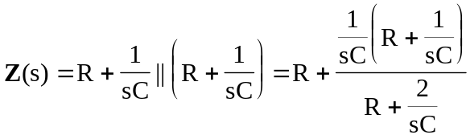
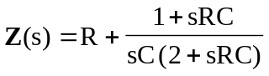
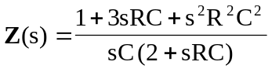

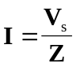
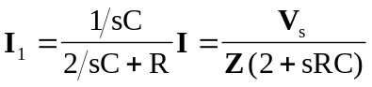

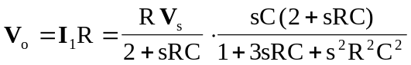

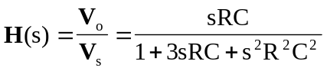

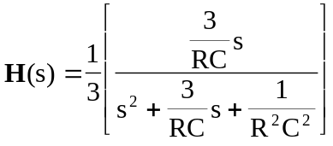

Thus, 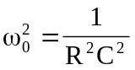 or 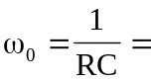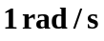
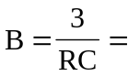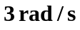

- Similarly,
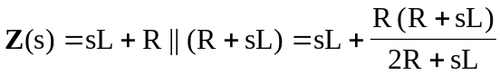
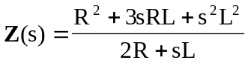

, 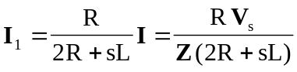

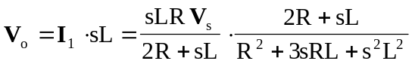

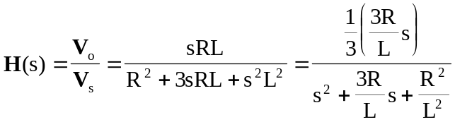

Thus, 